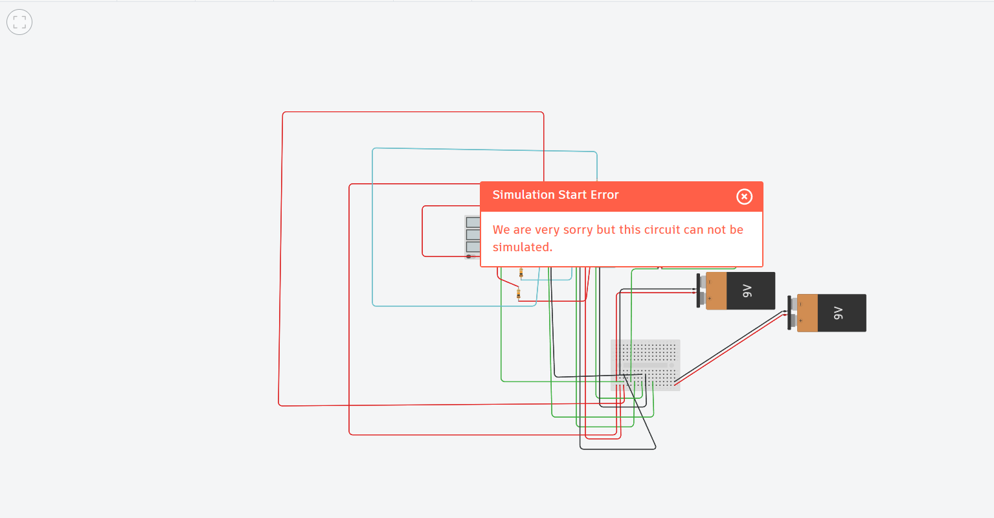

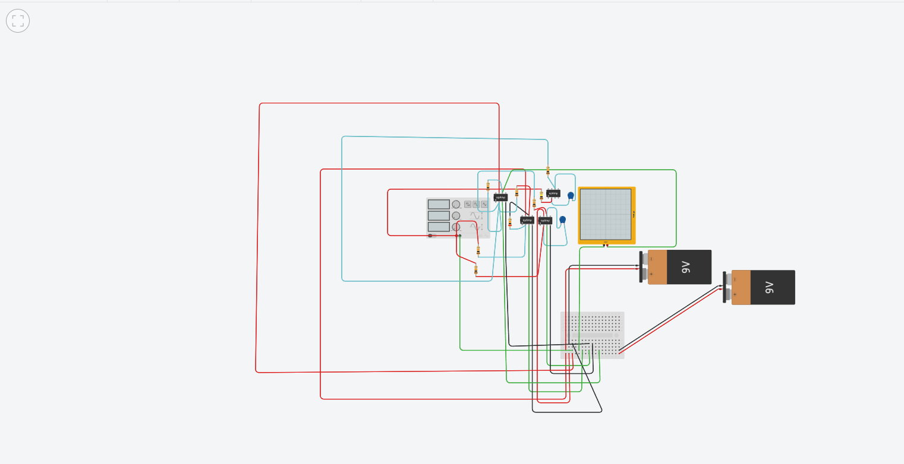

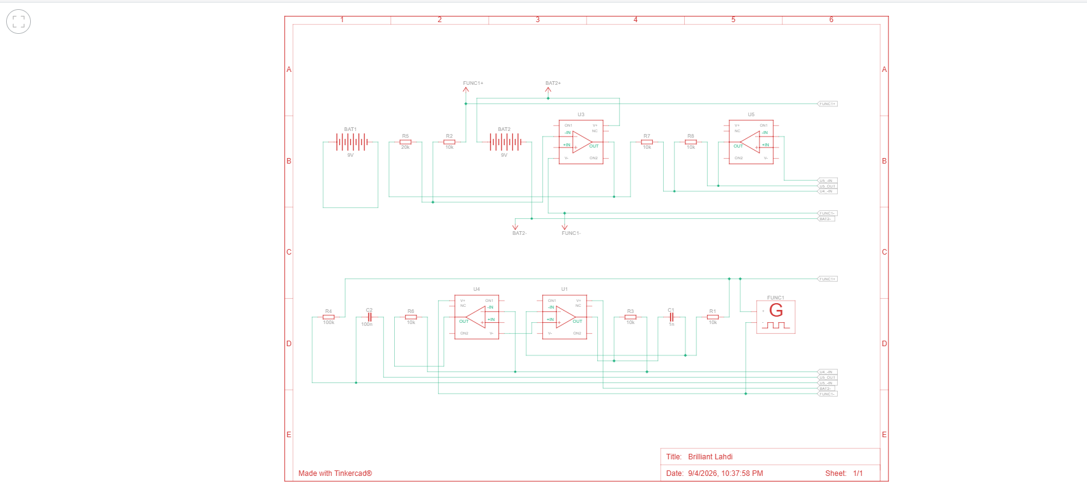

Link to tinkercad - https://www.tinkercad.com/things/3tSk3SbClNm-brilliant-lahdi/editel?returnTo=https%3A%2F%2Fwww.tinkercad.com%2Fdashboard

